**FMCG Export Sales Data Analysis**

**Unlocking Trends, Pricing, and Regional Insights**

**Niraj Chaudhari 2023JULB01102**

**INTRODUCTION**

This report presents an analysis of FMCG export sales data spanning from April 2019 to the present, focusing on key metrics such as product categories, customer codes, destination countries, quantities sold, and total prices. The goal is to uncover sales trends, assess category performance, evaluate regional dynamics, and analyze pricing strategies. By leveraging Power BI, the report visualizes these insights to guide strategic decisions, optimize product offerings, and identify growth opportunities in emerging markets.

The analysis aims to provide actionable insights that will help the business enhance sales performance by identifying top-performing categories, exploring untapped regions, and fine-tuning pricing strategies to maximize profitability. The visualizations enable stakeholders to make informed decisions based on real-time data, ensuring agility in a competitive FMCG market.

**1. Problem Statement**

In the competitive FMCG industry, export sales are critical to maintaining market share and expanding global reach. The challenge lies in identifying trends, understanding customer and regional performance, and optimizing product pricing and portfolio to align with market demands. Specific problems include:

* **Sales Trends:** How have quantities sold changed over time?
* **Regional Performance:** Which countries or regions contribute the most to sales, and which are underperforming?
* **Category Contribution:** Which product categories generate the highest sales, and how diverse is the product range within each category?
* **Pricing Dynamics:** How do product prices vary across regions and customers? Are pricing strategies aligned with regional purchasing power?
* **Actionable Insights:** What areas should businesses focus on to maximize profitability and growth?

The objective is to address these questions through data-driven insights using a robust visualization platform.

**2. Data Requirement**

To ensure a comprehensive and accurate analysis of FMCG export sales, specific data points were identified as essential for uncovering actionable insights. These requirements are structured into the following categories:

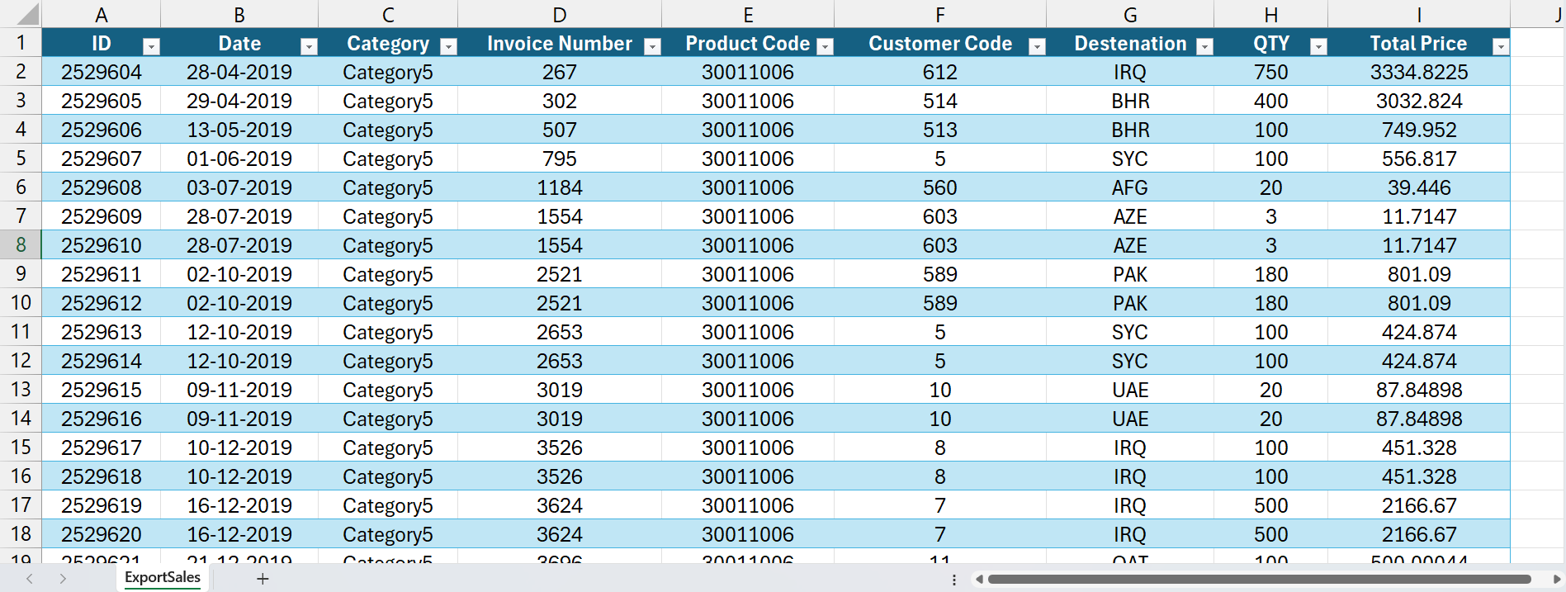

**A. Product Information**

* Product Category: Groups products for category-wise sales insights.
* Unique Product Code: Tracks individual product performance.
* Price: Captures dynamic pricing across time, customers, and regions.

**B. Customer Information**

* Customer Code: Identifies sales by customer for segmentation.
* Destination Country (ISO Code): Standardizes geographical data for region-wise analysis.

**C. Sales Transaction Data**

* Invoice Number: Tracks sales transactions, including multi-item sales.
* Quantity Sold (QTY): Indicates demand and popularity across products and regions.

**D. Time-Related Information**

* Sales Period: Analyzes trends by year and quarter, identifying seasonality and disruptions.

**E. Derived Metrics**

* Average Price: Highlights premium pricing and discounting trends.
* Sales Contribution: Evaluates the relative importance of categories and regions.

**F. Contextual Information**

* Historical Context: Data spans April 2019 to the present, enabling trend analysis.
* Regional Segmentation: Breaks down performance by global regions.

These data requirements form the foundation for effective decision-making and the creation of actionable business strategies.

**3. Data Collection**

The data was sourced from a commercial sales database that captures all transactions from April 2019 onward. Key features of the dataset include:

* **Multi-Item Invoices:** Invoices may contain multiple items, allowing analysis of order sizes and customer preferences.
* **Dynamic Pricing:** Prices vary across time, regions, and customer segments, enabling the study of pricing strategies.
* **Geographical Reach:** Data includes destination countries worldwide, categorized using ISO alpha-3 codes for consistency.

The dataset provides a foundation for building a detailed understanding of sales performance.

**4. Data Validation**

To ensure the data was reliable and fit for analysis, a thorough validation process was undertaken:

* **Duplicate Entries:** Removed duplicate rows to prevent inflation of sales quantities or revenues.
* **Consistency Checks:** Verified that product categories, customer codes, and destination countries aligned with standard formats.
* **Missing Data:** Addressed null values in critical fields (e.g., prices and quantities). Missing quantities were excluded, while missing prices were imputed based on average values for similar products.
* **Range Checks:** Checked that quantities and prices fell within expected ranges, flagging outliers for review.
* **Cross-Validation:** Compared customer codes and destination countries for mismatches, ensuring the data represented actual sales transactions.

**5. Data Cleaning**

The validated data underwent cleaning to prepare it for analysis:

* **Formatting:** Ensured uniform data formats, such as date fields for time-series analysis and standardized country codes.
* **Handling Outliers:** Addressed extreme outliers in quantities and prices to avoid skewing results. Outliers were reviewed and either corrected or excluded.
* **Consolidation:** Grouped data by relevant dimensions (e.g., quarter, year, and category) to simplify analysis and visualization.
* **Redundancy Removal:** Eliminated columns that did not contribute to the analysis objectives, streamlining the dataset.

These steps ensured the dataset was accurate, complete, and analysis ready.

**6. Tools**

The following tools were used at various stages of the analysis:

* **Microsoft Excel:**
  + **Data Exploration:** For initial inspection of the dataset.
  + **Cleaning and Formatting:** Handled missing values, standardized formats, and removed duplicates.
  + **Pivot Tables:** Provided quick summaries to validate aggregated metrics.
* **Power BI:**
  + **Data Modelling:** Created relationships between tables (e.g., linking product codes to categories and countries to regions).
  + **DAX Functions:** Generated calculated measures such as total sales, average prices, and category contributions.
  + **Visualizations:** Built interactive dashboards using visuals like line charts, pie charts, maps, and bar charts.
  + **Filters:** Enabled dynamic filtering for drilling down into specific time periods, regions, or categories.

**7. Dashboard**

The Power BI dashboard presents the analysis in an interactive and visually appealing manner, making insights accessible to stakeholders.

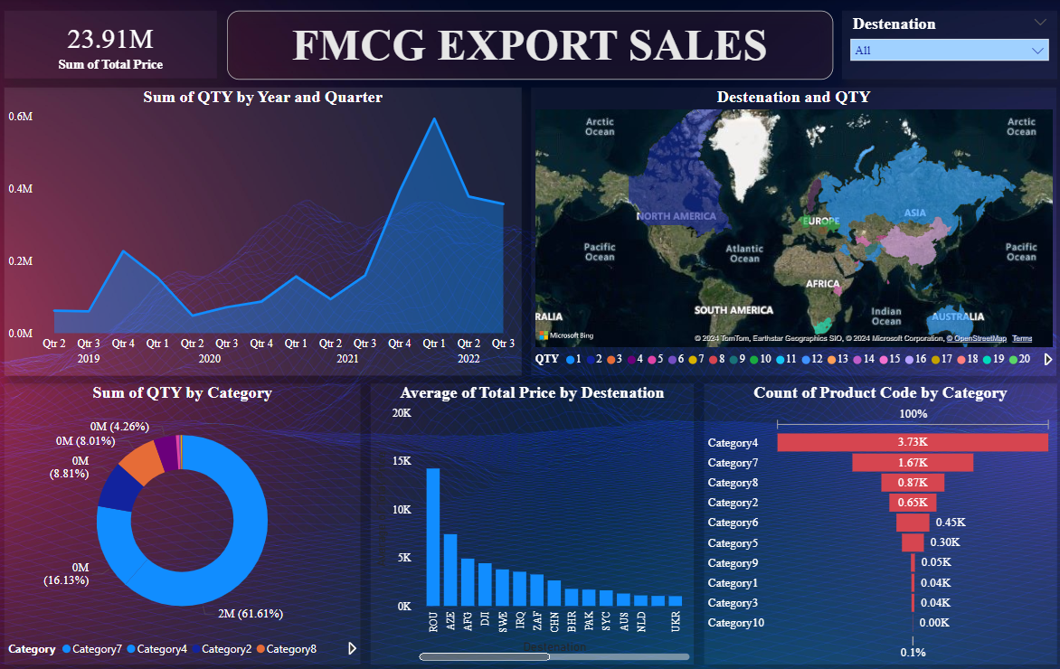

**Key Elements:**

1. **Title:** "FMCG Export Sales" immediately establishes the focus of the dashboard.
2. **Line Chart:**
   * **Metric:** Sum of Quantities (QTY) by Year and Quarter.
   * **Insights:** Reveals sales trends, including:
     + An upward trend from 2019 to early 2020.
     + A significant dip in 2020, likely due to global disruptions (e.g., COVID-19).
     + A recovery in 2021 and consistent performance in 2022.
   * **Action:** Highlights the need to investigate factors driving the recovery.
3. **Map Visualization:**
   * **Metric:** Destination-wise Quantity (QTY).
   * **Insights:** Visualizes the geographical distribution of sales, identifying high-performing regions such as Europe, Asia, and North America.
   * **Action:** Suggests focusing marketing and distribution efforts on underperforming regions.
4. **Pie Chart:**
   * **Metric:** Sum of QTY by Category.
   * **Insights:** Shows category-wise contributions, with Categories 7 and 4 dominating sales (61.61% and 16.13%, respectively).
   * **Action:** Reaffirms the importance of these categories while exploring opportunities to boost lesser-performing ones.
5. **Bar Chart (Vertical):**
   * **Metric:** Average Total Price by Destination.
   * **Insights:** Highlights regional variations in pricing. Regions like UAE and South Africa exhibit higher average prices, suggesting premium product sales or pricing strategies.
   * **Action:** Evaluate pricing models in other regions to identify potential for revenue growth.
6. **Bar Chart (Horizontal):**
   * **Metric:** Count of Product Code by Category.
   * **Insights:** Indicates diversity within each product category, with Category 4 showing the highest variety.
   * **Action:** Consider streamlining or expanding product lines based on performance.
7. **Slicer:**
   * **Function:** Allows users to filter by destination, enabling granular analysis.

**8. Storytelling**

**Unveiling FMCG Export Sales Insights**

The **dashboard narrative** reveals a journey of growth, resilience, and strategic opportunities:

* **Growth Over Time**: Sales steadily grew from 2019 to 2022, with a pandemic-related dip in 2020, followed by a strong recovery in 2021 and record-high sales in 2022.
* **Category Insights**: Category 7 dominates sales (61%), while underperforming categories indicate potential for diversification and targeted campaigns.
* **Regional Trends**: Strong sales in Europe, Asia, and North America, with premium pricing in the UAE and South Africa. Untapped markets like South America present growth opportunities.
* **Pricing Dynamics**: Regional pricing strategies reflect varying customer preferences, balancing premium markets with price-sensitive regions.
* **Product Focus**: Category 4 leads in product diversity, highlighting strategic focus areas.

**Key Message**: The story highlights adaptability, category strengths, and regional potential, guiding strategies to sustain growth, enhance profitability, and expand globally.

**Conclusion**

This detailed analysis of FMCG export sales highlights key trends, regional performance, category contributions, and pricing variations. By leveraging tools like Power BI, the dashboard provides an interactive and comprehensive view of business performance. Businesses can use these insights to:

* Focus on high-performing regions and categories.
* Reassess pricing strategies for underperforming markets.
* Streamline product portfolios based on sales trends.

Future improvements could include incorporating forecasting models, adding KPIs (e.g., revenue growth), and enhancing interactivity with deeper drill-down capabilities. This approach ensures sustained growth and profitability in the competitive FMCG sector.